**SPH3U: 3.5 Using Newton’s Laws**

1. **Tension and Newton’s laws**

|  |  |
| --- | --- |
| Tension: |  |
| Newton’s third law |  |
| ignoring tension |  |

Each object below has a force of gravity of 120 N [down] acting on it. Determine the tension in each string.

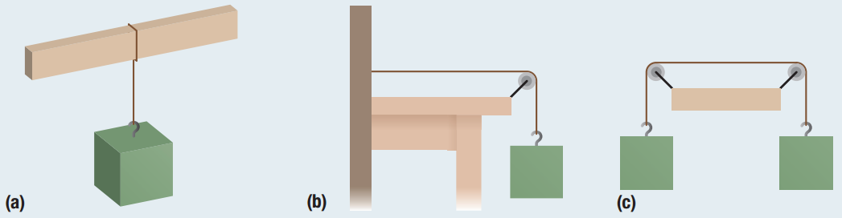

Three sleds are tied together and pulled east across an icy surface with an applied force of 12 N [E]. The mass of sled 1 is 12.0 kg, the mass of sled 2 is 11.0 kg, and the mass of sled 3 is 7.0 kg. Assume there is no friction.

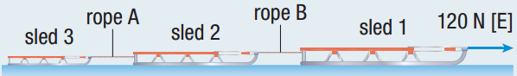

1. Determine the acceleration of the sleds.
2. Calculate the magnitude of the tension in rope A.
3. Calculate the magnitude of the tension in rope B.
4. **Kinematics and Newton’s laws**

|  |  |
| --- | --- |
| Kinematics equations: |  |

Starting from rest, an ice skater (54.0 kg) pushes the boards with a force of 130.0 N [W] and moves 0.704 m. He then moves at a constant velocity for 4.00 s before he digs in his skates and starts to slow down. When he digs in his skates, he causes a net force of 38.0 N [W] to slow him down until he stops.

1. Determine the acceleration of the skater
2. when he is pushing on the boards
3. just after he stops pushing on the boards
4. when he starts to slow down
5. How far does he move?

**Homework:** page 147: #1-2, 4-6